|  |  |
| --- | --- |
| **Ex. No. 9** | **Form Validation and Routing using Angular JS** |
| **Date of Exercise** | **26.10.22** |
| **Web Host Link** |  |
| **Youtube Link** | https://drive.google.com/file/d/1BC4alTBNAhgT35r26uzfQCFQdcVMl5FQ/view?usp=share_link |

**Aim**

1. To Design User Registration Page as per the following design and perform validation of each fields and generate error message if the field is not correct as per the following constraints.

2. To Design your own website using HTML, Angular JS Routing and CSS for any application as per your choice with minimum 4 pages and proper content including text, forms, media etc.

**Description**

* Input controls provides data-binding by using the ng-model directive.
* The ng-model directive binds the input controller to the rest of your application.
* The property firstname, can be referred to in a controller
* The property secondname, can be referred to in a controller
* And repeat the same thing for email and password
* Use ‘required’ to check whether all the text are filled in the text area.
* Use checkboxes to let the users give feedbacks about their experience
* Apply the ng-model directive to a checkbox, and use its value in your application.
* Bind radio buttons to your application with the ng-model directive.
* Use radio buttons to let the users to give ratings .
* Radio buttons with the same ng-model can have different values, but only the selected one will be used.

**Program**

**Program 1:**

<!DOCTYPE html>

<html lang="en">

<head>

    <title>User Registration Form</title>

    <script src="https://ajax.googleapis.com/ajax/libs/angularjs/1.6.9/angular.min.js"></script>

    <script>

        var app = angular.module('myapp', []);

        app.controller('mycontrol', function($scope){

            $scope.namepattern = /[a-zA-Z]/;

            $scope.passpattern = /^[a-zA-Z0-9]{10}$/;

            $scope.mobpattern = /[0-9]{10}/;

            $scope.agepattern = /[0-9]{2}/;

        });

    </script>

</head>

<body ng-app="myapp" ng-controller="mycontrol">

    <h1 style="color: blue;margin: 30px;">User Registration Form</h1>

    <form name="myform" style="margin: 5px 30px;">

        Name<span style="color: red;">*</span> &emsp;&emsp;&emsp;&emsp;&emsp;

        <input type="text" name="myname" ng-model="name" ng-pattern="namepattern" required>

        <span style="color: red;" ng-show="myform.myname.$dirty && myform.myname.$error.required">Name is required...</span>

        <span style="color: red;" ng-show="myform.myname.$dirty && myform.myname.$error.pattern">Name Format is wrong...</span><br><br>

        Password<span style="color: red;">*</span>&emsp;&emsp;&emsp;&emsp;

        <input type="password" name="mypassword" ng-model="password" ng-pattern="passpattern" required>

        <span style="color: red;" ng-show="myform.mypassword.$dirty && myform.mypassword.$error.required">Password is required...</span>

        <span style="color: red;" ng-show="myform.mypassword.$dirty && myform.mypassword.$error.pattern">Password Format is wrong...</span><br><br>

        Age<span style="color: red;">*</span> &emsp;&emsp;&emsp;&emsp;&emsp;&emsp;

        <input type="number" name="myage" ng-model="age" ng-pattern="agepattern" required>

        <span style="color: red;" ng-show="myform.myage.$dirty && myform.myage.$error.required">Age is required...</span>

        <span style="color: red;" ng-show="myform.myage.$dirty && myform.myage.$error.pattern">Not eligible...</span><br><br>

        Mobile Number <span style="color: red;">*</span> &emsp;

        <input type="number" name="mymobilenum" ng-model="mobilenum" ng-pattern="mobpattern" required>

        <span style="color: red;" ng-show="myform.mymobilenum.$dirty && myform.mymobilenum.$error.required">Mobile Number is required...</span>

        <span style="color: red;" ng-show="myform.mymobilenum.$dirty && myform.mymobilenum.$error.pattern">Format is wrong...</span><br><br>

        Email<span style="color: red;">*</span>&emsp;&emsp;&emsp;&emsp;&emsp;&ensp;

        <input type="email" name="mymail" ng-model="mail" required>

        <span style="color: red;" ng-show="myform.mymail.$dirty && myform.mymail.$error.required">Email is required...</span>

        <span style="color: red;" ng-show="myform.mymail.$dirty && myform.mymail.$error.email">Email Format is wrong...</span><br><br>

        Gender<span style="color: red;">*</span> &emsp;&emsp;&emsp;&emsp;&ensp;

        <input type="radio" name="mygender" ng-model="male" required>Male

        <input type="radio" name="mygender" ng-model="female" required>Female<br><br>

        State<span style="color: red;">*</span> &emsp;&emsp;&emsp;&emsp;&emsp;&emsp;

        <select name="mystate" id="state">

            <option value="Odisha">Odisha</option>

            <option value="Tamilnadu">Tamilnadu</option>

            <option value="Gujurat">Gujurat</option>

            <option value="Kerala">Kerala</option>

        </select><br><br>

        <button type="submit">Submit</button>

    </form>

</body>

</html>

**Program 2:**

**Index.html**

<!DOCTYPE html>

<html lang="en">

<head>

    <meta charset="UTF-8">

    <meta http-equiv="X-UA-Compatible" content="IE=edge">

    <meta name="viewport" content="width=device-width, initial-scale=1.0">

    <link rel="stylesheet" href="style.css">

    <script src="https://ajax.googleapis.com/ajax/libs/angularjs/1.6.9/angular.min.js"></script>

    <script src="https://ajax.googleapis.com/ajax/libs/angularjs/1.6.9/angular-route.js"></script>

    <script>

        var app = angular.module('myapp', ['ngRoute']);

        app.config(function($routeProvider){

            $routeProvider.when('/login', {

                templateUrl: 'login.html'

            })

            .when('/register', {

                templateUrl: 'register.html'

            })

            .when('/about', {

                templateUrl: 'about.html'

            })

            .when('/contact', {

                templateUrl: 'contact.html'

            })

        });

    </script>

</head>

<body ng-app="myapp">

    <h1>Teaching Dashboard</h1>

    <hr>

    <div class="sidebar">

        <a href="#!login">Login</a>

        <a href="#!register">Sign Up</a>

        <a href="#!contact">Contact</a>

        <a href="#!about">About Us</a>

    </div>

    <div class="content" ng-view>

    </div>

</body>

</html>

**login.html**

<h1>Login Here!!!</h1>

<br>

<form>

    Email: <input type="text"><br><br>

    Password: <input type="password"><br><br>

    <button type="submit" style="margin-left: 1; background-color: rgb(0, 0, 0); color: gold; font-weight: bold;">Login</button>

</form>

**Register.html**

<h1>Welcome to New User Registration!</h1>

<br>

<form>

    Name: <input type="text"><br><br>

    Email: <input type="email"><br><br>

    Phone: <input type="text"><br><br>

    Password: <input type="password"><br><br>

    <button type="submit" style="margin-left: 0; background-color: rgb(0, 0, 0); color: gold; font-weight: bold;">Register</button>

</form>

**Contact.html**

<h1>Contact</h1>

<div style="padding: 30px;">

    <p>Mobile Number: 6353082863 </p>

    <a href="https://www.facebook.com/" style="margin-left: 0; background-color: rgb(0, 0, 0); color: gold; font-weight: bold;">Facebook</a>

    <a href="https://www.instagram.com/" style="margin-left: 0; background-color: rgb(0, 0, 0); color: gold; font-weight: bold;">instagram</a>

</div>

**About.html**

<h1>About Us</h1>

<br>

<p>&emsp;&emsp;&emsp;Hello learners, Myself Sumeet Kumar Gamango your learning guide. I have a professional background in technical concepts. I have a great experience in Python,C/C++. Here I am going to tell about all the Technical concepts in dept knowledge. Introduce students to the expectations of research in your discipline. Guide students through the technical practices needed to support project goals (e.g., protocols for labs, databases, studios, archives, software). Emphasize the importance of ethical standards and safety.</p>

<p>&emsp;&emsp;&emsp;Technology is the application of knowledge to reach practical goals in a specifiable and reproducible way. The word technology may also mean the product of such an endeavor. The use of technology is widely prevalent in medicine, science, industry, communication, transportation, and daily life. Technologies include physical objects like utensils or machines and intangible tools such as software.</p>

**Style.css**

*{

    margin: 0;

}

html, body{

    height: 100%;

}

h1{

    text-align: center;

    padding: 16px;

    color: rgb(239, 210, 210);

    background-color: #000000;

}

.sidebar{

    width: 19%;

    height: 100%;

    float: left;

    border-right: 1px solid rgb(155, 153, 153);

    text-align: center;

}

a{

    font-size: 20px;

    width: 120px;

    text-align: center;

    border-radius: 8px;

    margin: 32px 70px;

    text-decoration: none;

    color: gold;

    background-color: #000000;

    padding: 8px;

    display: block;

}

.content{

    width: 77.5%;

    height: 100%;

    float: left;

    border: 1px solid gold;

    padding: 18px;

    color: gold

}

p{

    font-size: 24px;

    line-height: 0 32px;

    text-align: justify;

    width: 96%;

    margin-top: 16px;

    color: gold

}

**Output**

Output 1:

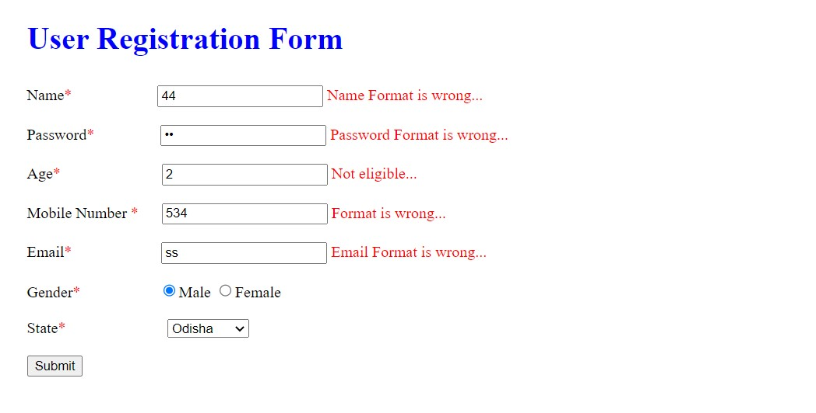

Output 2:

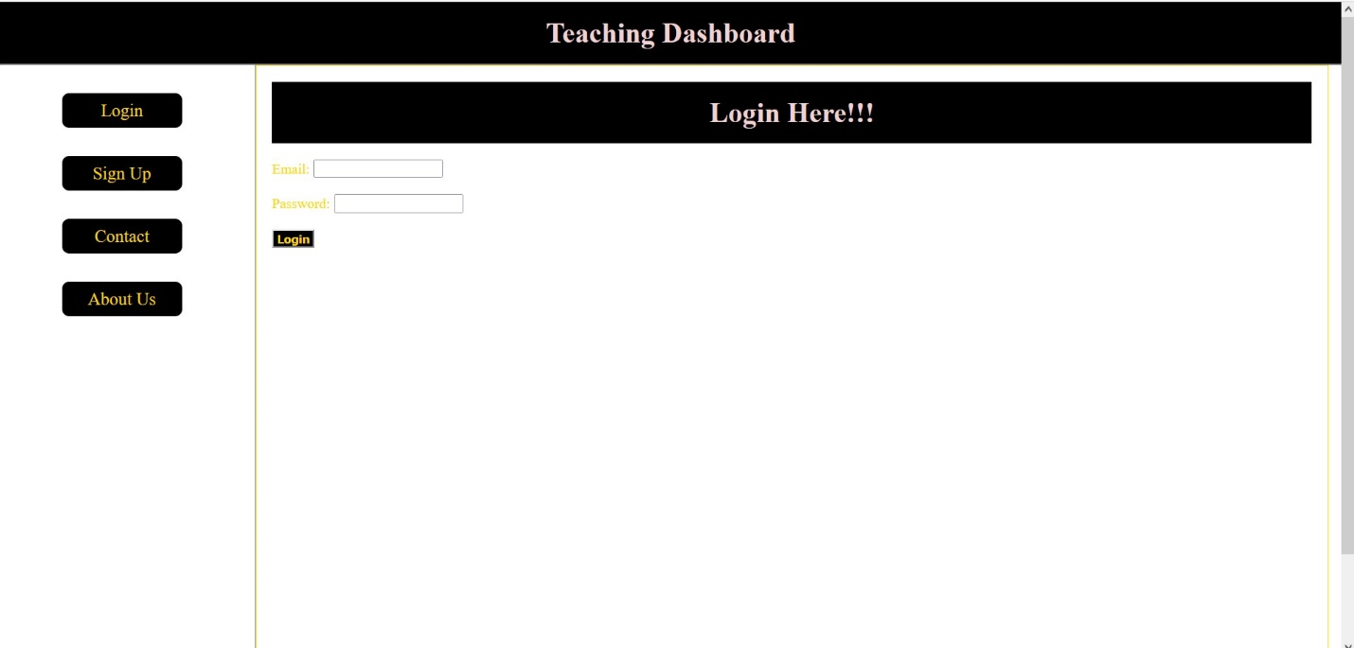

**Result**

Thus, the website design using Angular JS has been written and executed successfully.